REPORT FROM FACULTY CONGRESS-Dr. Lowell Gustafson
The seal of the university is at the base of the spiral staircase in the St. Augustine Center for the Liberal Arts, a building in which many faculty have their offices. This seal portrays the symbols of the foundation of this university, including a passionate commitment to understanding and love, recognition of life’s many trials and tests, the need for responsible leadership, a search for transformation and commitment, and a confidence in the success to be gained through the pursuit of knowledge in the context of lasting relationship. It is possible while climbing the staircase to trip on memos, newsletters, resolutions, deadlines, emails, curriculum vitae, reports, unintended slights, and a thousand other steps that must be taken. Most of the time, the staircase leads to places where we can read and write, meet with our students, and hold conversations with our colleagues. Sometimes, as we ascend this staircase, we notice its apogee, with its windows that open the view to the skies and welcome the light.

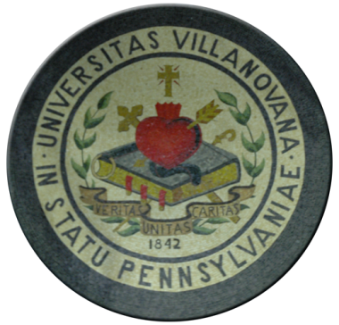
At those times, we make use of our God-given faculties of sight, hearing, memory, and speech as we seek to develop our abilities, our faculties to make friends, to learn, to reason together. When we meet with each other to discuss our common interests, when we associate with each other, when we come together, then we meet in congress. When we succeed in this Faculty Congress, we touch the soul of the university, the soul that calls its students from around this commonwealth, this country, this world.

It was in that spirit that Fr. Peter, Dr. Johannes, and the deans of Arts and Sciences, Business, Engineering, and Nursing addressed the Faculty Congress this year, offering their views of how this university can build on its foundations and how faculty are integral in the construction of university wide programs. As a result, faculty in all the colleges have initiated a range of common projects, such as those in Entrepreneurship, Political Economy, International Business and Culture, and many others. Boundaries between departments and colleges are being re-examined as interactions between them increase. At our meeting with him, Dean Danko praised the theology major who later gets an MBA and commits to a life creating wealth for a world in need.

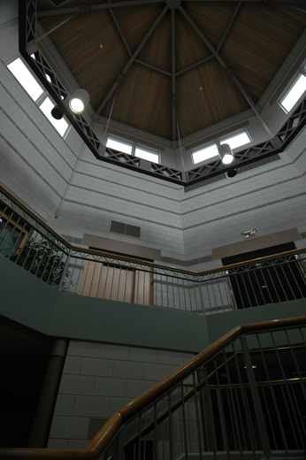
In an era of globalization in which the meanings of national boundaries are changing, the mission of a catholic university has grown to include the humanization of world affairs – the transformation of purely economic transactions to an appreciation of common obligations and relations – of unitas and caritas – among wonderfully diverse peoples. Villanova’s motto is not to be repeated mindlessly, but to serve as an inspiration to offer creative options to a world too often caught in myopia.

A variegated faculty with diverse abilities and strengths contributes to this important task. Adjunct faculty and tenure track faculty have each formally participated in university governance; now, following our recent referendum, the full time, non tenure track faculty too will have a defined place in our conversations.

The most transforming moment of St. Augustine’s life came when he responded to the call to “Take up and Read.” He then went on to also discuss and challenge and console and teach and learn and wonder. Faculty resonate to the call for a life long passion to do just that, and are justifiably proud to live in the light that shines on the foundation shared by the entire Villanova community, as together we climb toward the views of beyond.

VII. CONSTITUTIONAL AMENDMENT REGARDING COMMITTEE ON FACULTY AND ACADEMIC POLICY COMMITTEE
At the Rules and Review 30 Nov 2006 meeting, the committee recommended an amendme

